PROJECT REPORT

1.INTRODUCTION

1.1 Overview

An application tracking system (ATS) is software for recruiters and employers to track candidates throughout the recruiting and hiring process. This software can come equipped with capabilities ranging from simple database functionality to a full-service suit of tools that makes it easy for businesses of any size to filter ,manage, and analyze candidates.

1.2 Purpose

Recruitment need not be crazy difficult or too expensive.It can be smooth,fast,and efficient with good ATS like Freshteam.Recruiting new employees can become an overwhelming and expensive process. An Application Tracking System/ATS is used by companies to automate recruitment and keep costs significantly lower.Is ATS just meant for the big corporate? No, ATS for startups and small businesses can prove to be extremely useful too.

1.Steramtines recruiting

2.Posts jobs on multiple job boards

3.Saves time by automating mundane tasks

4.Buids your brand

2.PROBLEM DEFINITION &DESIGN THINKING

2.1 EMPATHY MAP

Paste the empathy map screenshot

2.2 Ideation & brainstorming map screenshort

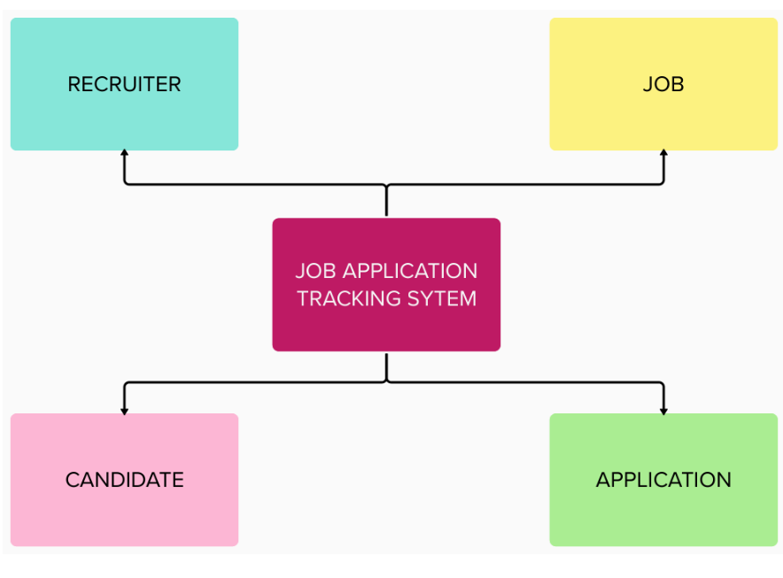

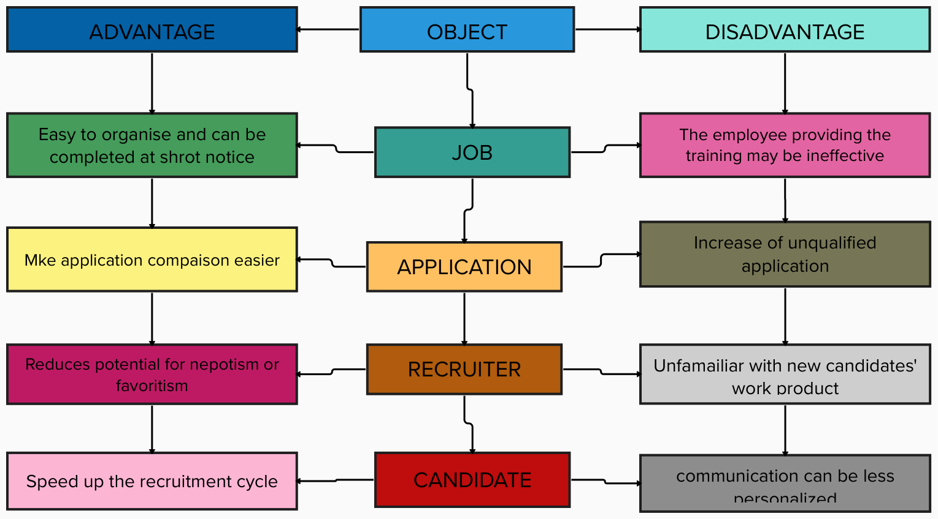

3.RESULT

3.1 Data Model

|  |  |  |
| --- | --- | --- |
| OBJECT NAME | Field in the object | |
| Job | Field label | Data Type |
| Principal  Teaching  Non-Teaching  Whatchman  Driver | Text  Text  Text  Text  Text |
| Application | Name  Age  Phone no  Qulification  Department | Text  Number  Number  Picklest  Picklest |
| Candidate | Candidate Name  Phone no  Aathar no  Email Id  Address | Text  Number  Number  Text  Text |
| Recruiter | Recruiter Name  Application no  Aathar no | Text  Text  Text |

3.2 Activity & Screenshot

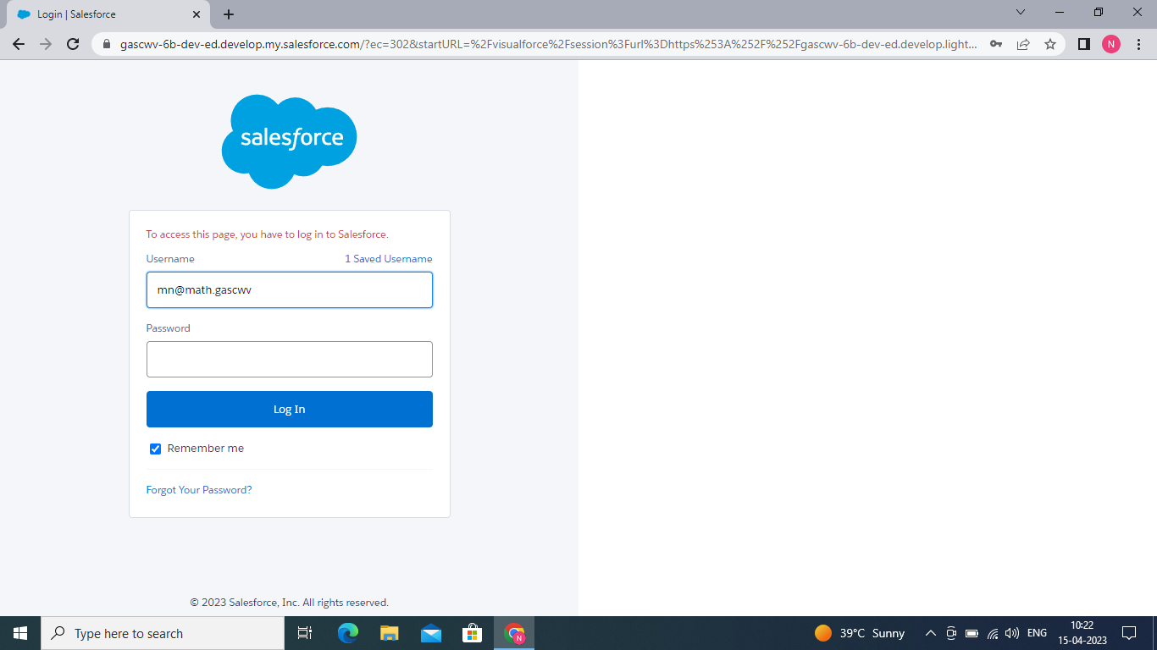

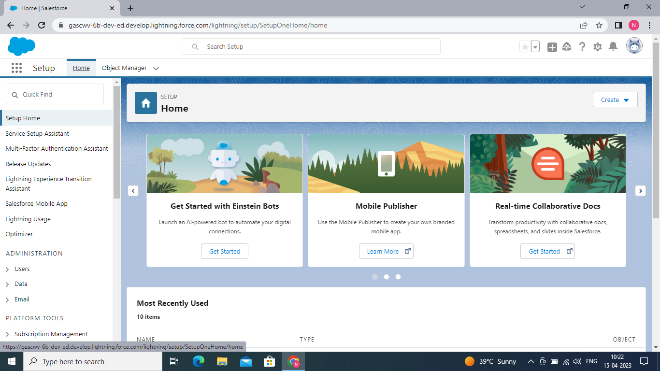

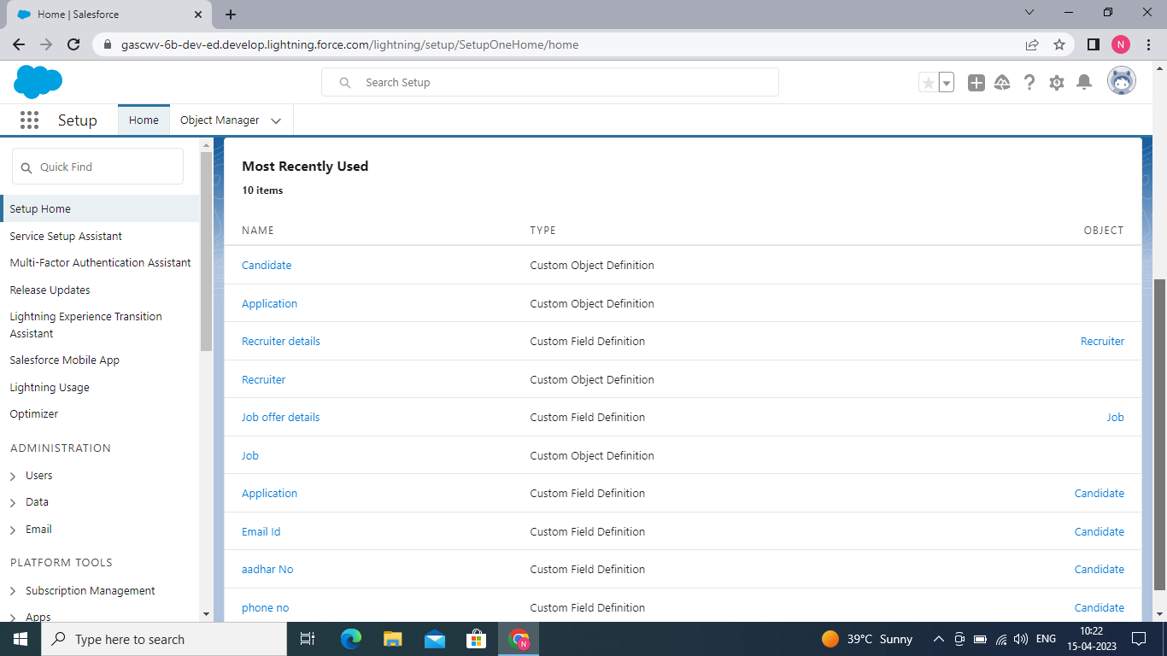

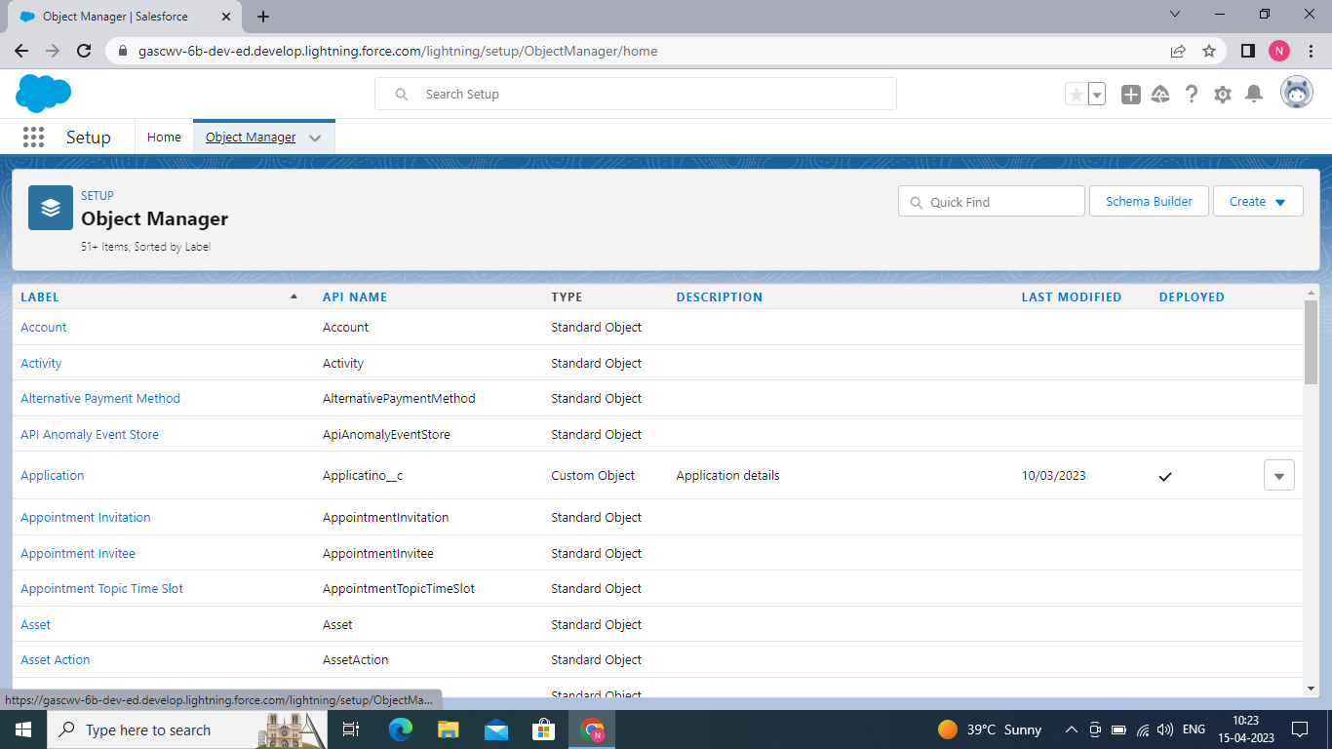

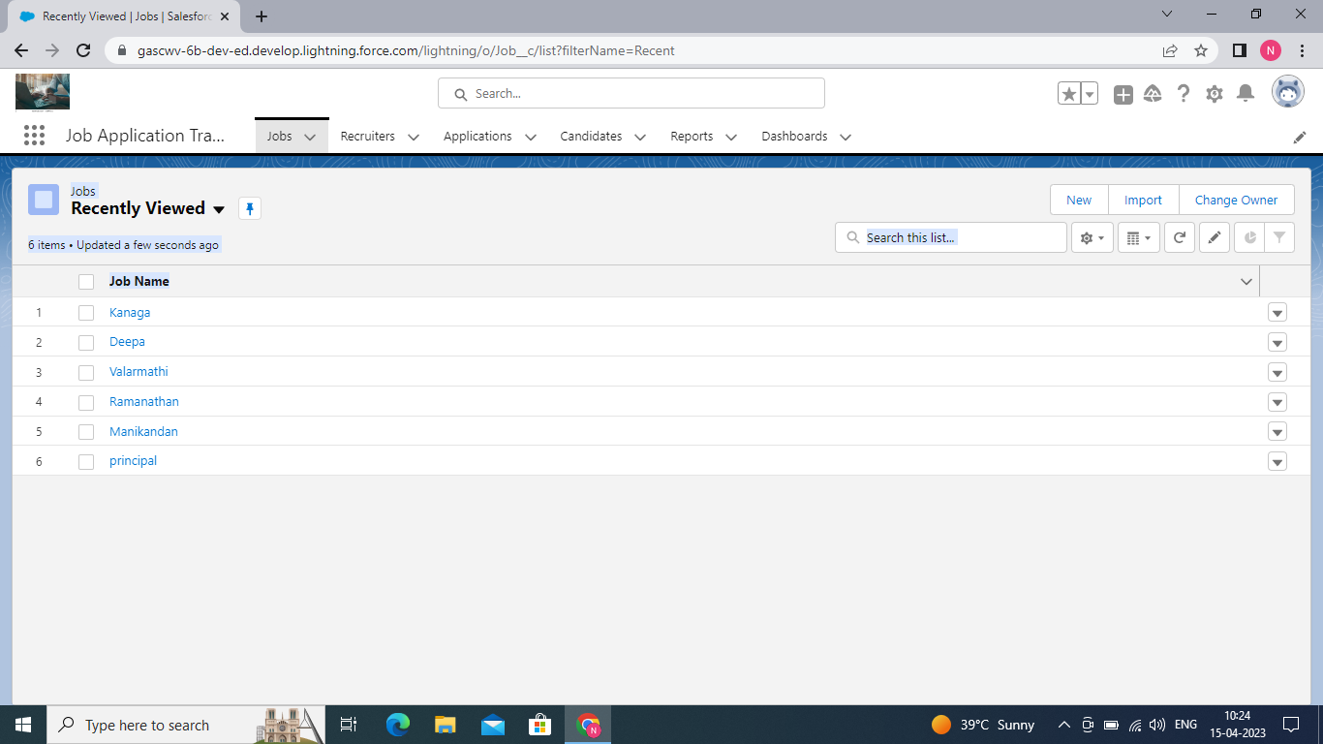

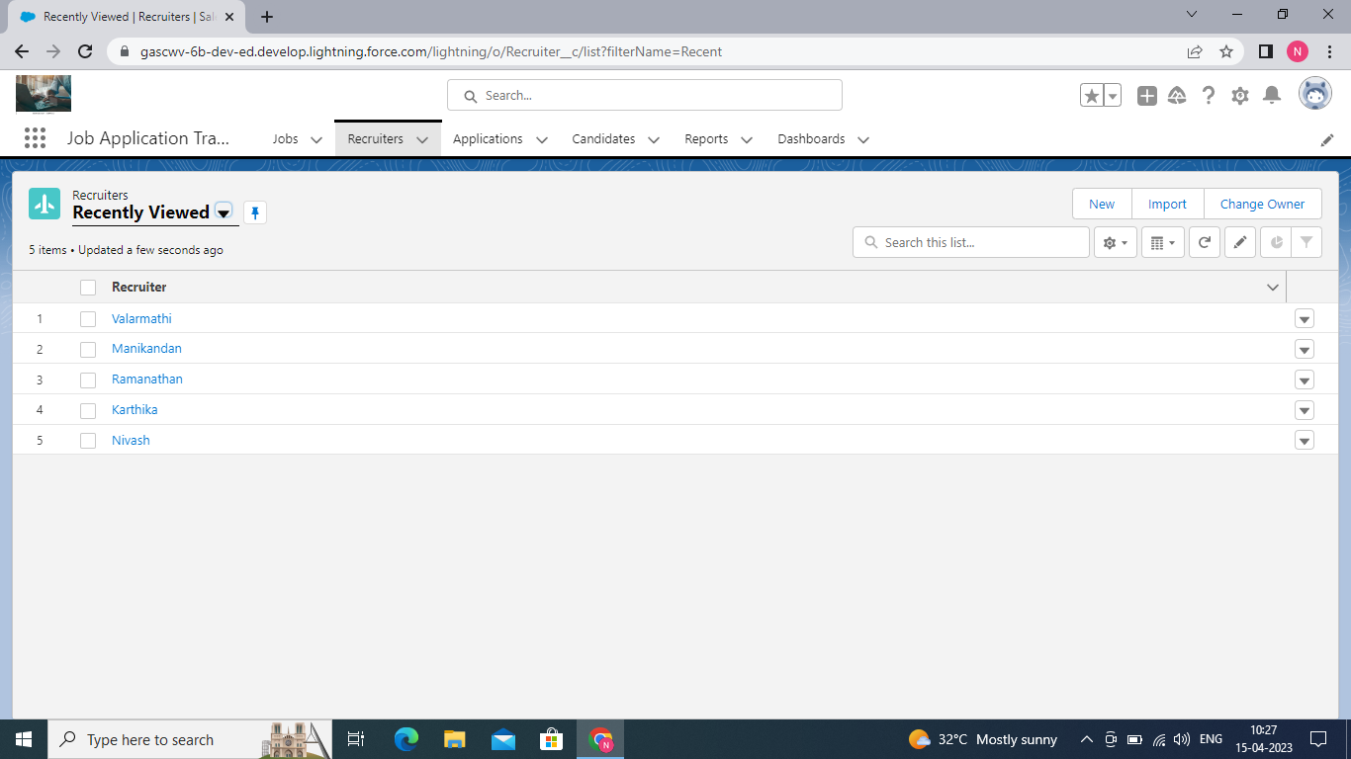

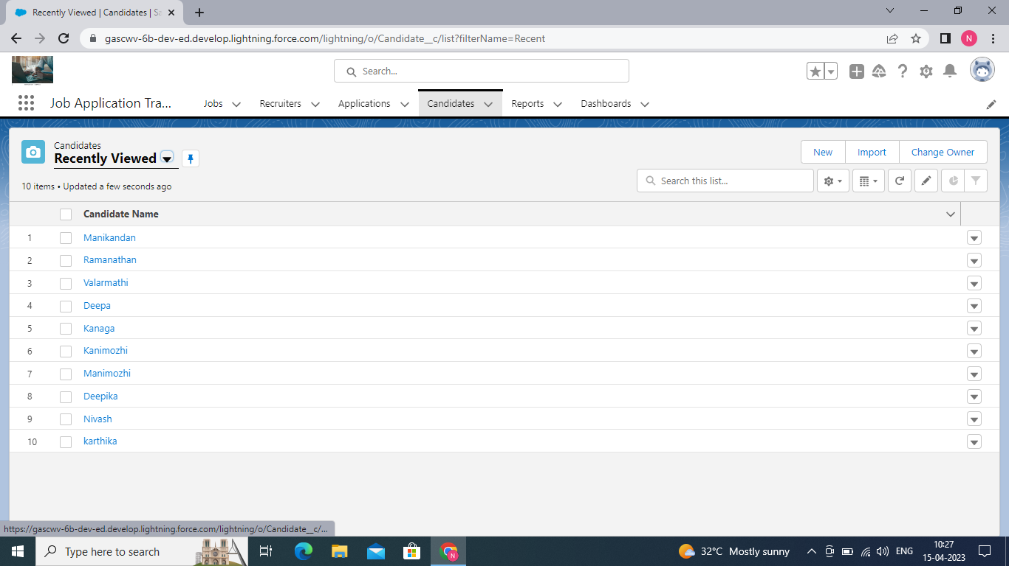

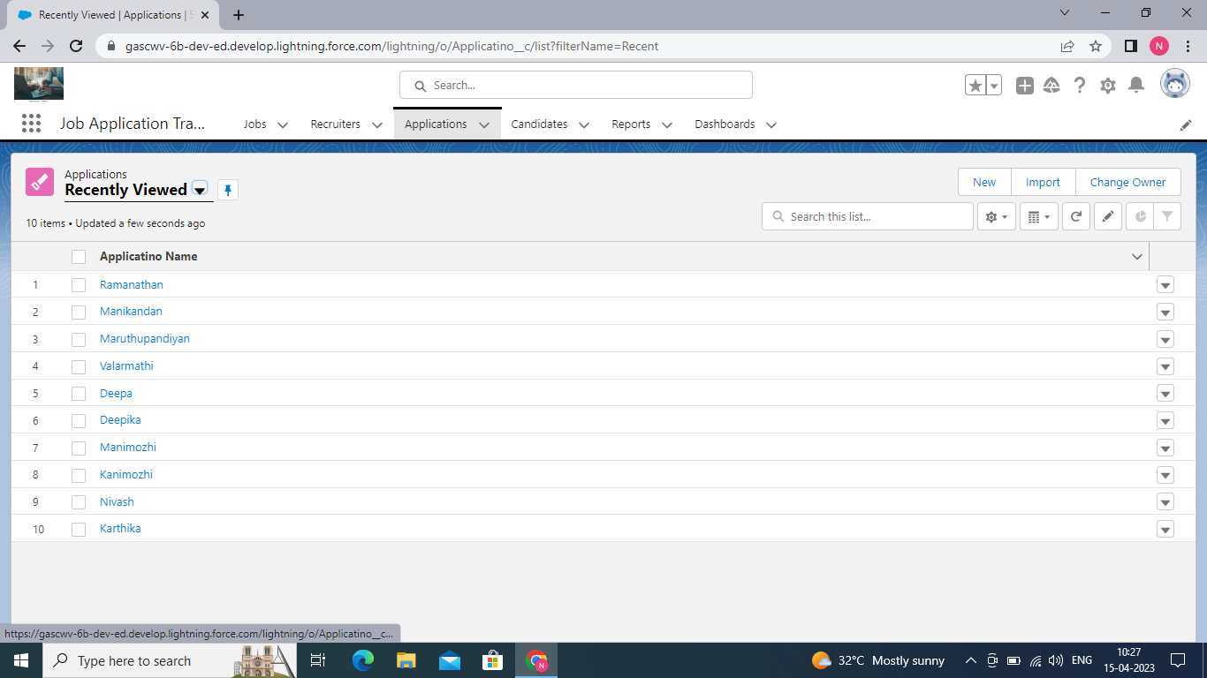

4.Trailhead Profiel Public URL

Team Lead - <https://trailblazer.me/id/nmahenthiran>

Team Members

C.Sivasankari - <https://trailblazer.me/id/ssankri>

M. Muthulakshmi - <https://trailblazer.me/id/mbalaji30>

R.Sowndharya - <https://trailblazer.me/id/sown3>

5.ADVANTAGE & DISADVANTAGE

JOB APPLICATION TRACKING SYSTEM ADVANTAGE :

1.Reduces time spent on admin tasks

2.Resume and CV screening

3.Speed up the recruitment

4.Improves the quality of hire

5.Enhances reporting and compliced

JOB APPLICATION TRACKING SYSTEM OF DISADVANTAGE:

1. Could filter out good candidates
2. Communication can be personalized

6. Application

When we asked recruiter about the main reasons for using Applicant Tracking System, this is what they said:

* Inability to source people with good skills and characteristics
* Manual rejection and feedback to candidates
* Manual and time consuming interview scheduling
* Extensive use of excel spreadsheets and emails
* Messy recruiting and selection process
* Inability to evaluate and measure the effectiveness of HR strategy
* Long time-to-hire
* High cost-to-hire
* Lack of talent pool management
* Poor and slow communication with candidates
* Poor and slow communication with candidates
* Hard to keep up with all the applications
* Poor quality-of-hire

7.Conclusion

When you apply for a job, your resume typically passes through an applicant tracking system (ATS) before reaching the hiring manager. This software helps streamline and automate the hiring process, allowing hiring professionals to focus on reviewing the most qualified or best-fit candidates for the job. Having knowledge of the ATS can help you create and submit applications that meet employers' requirements and standards. In this article, we discuss what an applicant tracking system is, what it does and how it works and share some tips for making your application materials compliant with the ATS program

8.FUTURE SCOPE

Coding is fast becoming one of the most sought-after skills for technology companies and between researcher groups. In a survey of over 500 tech workers and employers by Remote. That makes software developers the most highly-ranked job overall in the survey.

The increasing importance of programming has caused some European countries to add coding to the primary school curriculum – here in the UK, one school has even hired a child coding prodigy to [teach coding at a school](https://www.futurelearn.com/courses/teaching-programming-to-5-11-year-olds) in Coventry. How old do you think the new member of staff is? Well, she’s just ten years old!